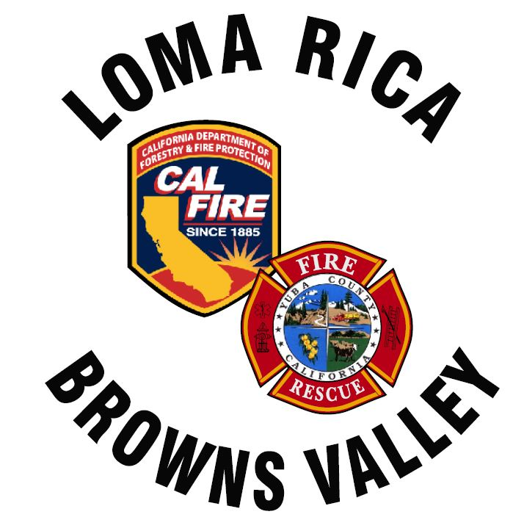
11485 Loma Rica Rd
Marysville, CA. 95901
530-741.0755
www.lrbvfire.org
lrbvcsd@lrbvfire.org
LOMA RICA/BROWNS VALLEY
COMMUNITY SERVICES DISTRICT

AGENDA
This meeting will be at 7:00pm at the Loma Rica Bi-Agency Fire Station
11485 Loma Rica Road Loma Rica, CA. 95901
This agenda has been prepared and posted at least 72 hours prior to the regular meeting of the Board in accordance with the Ralph M. Brown Act. All supporting documents are available, upon request, beginning at 6:30 pm the date of the meeting

DATE: June 15, 2026

- ROLL CALL: Biggs, High, Kattuah, McGahan, Yarborough
PLEDGE OF ALLEGIANCE
- PUBLIC COMMUNICATIONS
Any person my speak on any subject or matter of concern, provided the subject or matter is within the jurisdiction of the Board of Directors for Loma Rica/Browns Valley CSD and is not already on the agenda. The Board limits testimony on such matters to 5 minutes per person but not more that 15 minutes total on a particular topic. The entire Public Communications section shall be limited to a total of 20 minutes unless the Chairperson, subject to Board approval, sets different time limits.
NOTE: No Board action can be taken on comments made under this heading

- CONSENT AGENDA
  - APPROVAL OF MINUTES: May 18, 2026
  - ACCOUNTING: Financial reports for the month of June 2026
  - DISCUSS/APPROVE: Warrants for the expenses of June 2026
  - DISCUSS/APPROVE: 2025-2026 Amended Budget
  - DISCUSS/APPROVE: 2026-2027 FY Budget
    - Open Discussion to Public
    - Close Discussion to Public
    - Final approval for operating budget fiscal year 2026-2027

- CHIEF’S REPORT:
- VOLUNTEER REPORT:
- GENERAL MANAGER REPORT:

OLD BUSINESS

NEW BUSINESS

- DISCUSS AND APPROVE: Wharf valve installation (G. Yarborough.)
- DISCUSS AND APPROVE: The following Resolutions.

- 2026-02 Request and Authorization for the County of Yuba to Collect the Loma Rica/Browns Valley Community Services District Benefit Assessment for fiscal year 2026-2027.
- 2026-03 Request and Authorization for the County of Yuba to allow an annual automatic journal transfer of fees from the Loma Rica/Browns Valley Community Services District to the Yuba County Rural Fire Joint Powers Agency in the amount of $3000.00.

- CLOSED SESSION Government Code 54956.7, 54956.9, 54957.7
Liability Claims – Claimant: Cooper
  - Open Session
  - Action Taken

- BOARD AND STAFF MEMBER REPORT:

This time is provided to allow Board and Staff members to report on activities or to raise issues for placement on future agendas.

A segment of time will be open during each Agenda Item for Public Comment/Testimony

In compliance with the Americans with Disabilities Act, the meeting room is wheelchair accessible and disabled parking is available. Upon request, agendas will be made available in alternative formats to accommodate persons with disabilities. If you have a disability-related modification or accommodations to participate in tis meeting, please contact he district office at (530)741-0755 no later than 24 hours prior to the start of the meeting.

Board Packet: Available 30 minutes before the start of this meeting:
5/15/2026 Minutes
June Financial Reports
June Warrant request
“Petty Cash” transactions
2026/20274 DRAFT Budget
Chief’s Report
General Manager’s Report
Resolutions 2026-2 and 2026-3

