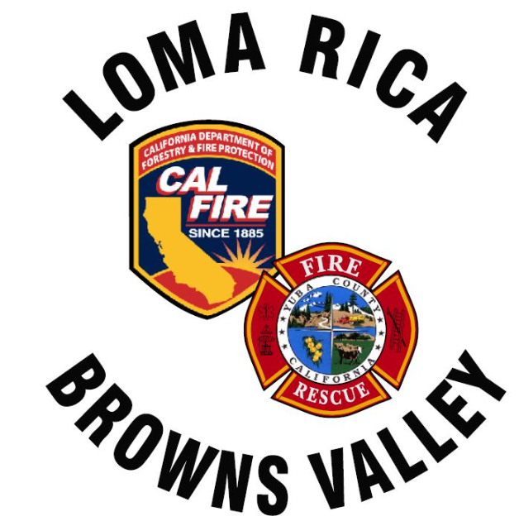
Monthly Report for LRBV

Month/Year: JUNE 2026

 | St. 61
Medical Aid | 23
Public Assists | 10
Medical Rescues | 0
Vehicle Accidents | 4
Structure Fires | 0
Vegetation Fires | 2
Vehicle Fires | 0
False Alarms | 4
Hazardous Conditions | 1
Hazardous Materials | 0
Cover Assignments | 0
Assist to Allied Agency | 0
Total Responses | 46

News:
Engine 63 rented out for 4 days
WT 62 ABH during red flag on the 10th and 11th.
One inquiry regarding Engine 62
Discussion items:
Remodel of 62- rendering ideas attached.

Agenda items:

