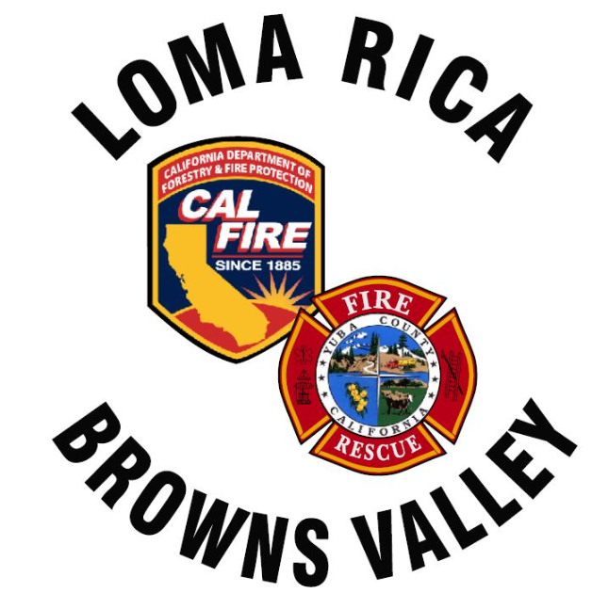
Monthly Report for LRBV

Month/Year: september, 2026

 | St. 61
Medical Aid | 43
Public Assists | 4
Medical Rescues
Vehicle Accidents | 6
Structure Fires | 2
Vegetation Fires | 5
Vehicle Fires
False Alarms | 2
Hazardous Conditions
Hazardous Materials
Cover Assignments
Assist to Allied Agency
Total Responses | 62

News:
WT 61 delivery couple weeks. Few items to address before delivery
Engine 62 and 63 ABH (august and September)
LAFCO 5 year survey went well.
Waiting on second contractor bid for station 62.
Station 62 water tank has many pin holes leaking water. Working on a fix.

