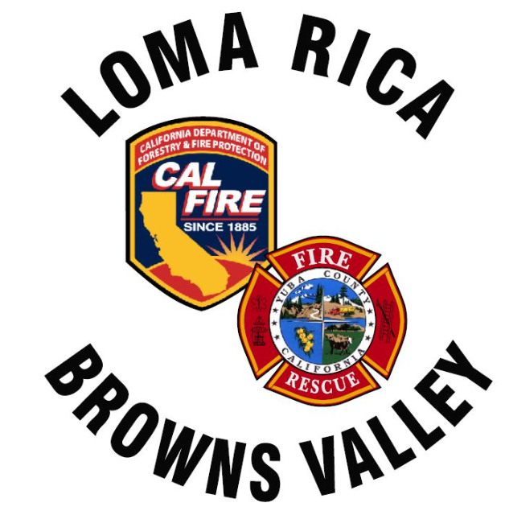
Monthly Report for LRBV

Month/Year: July/August, 2026

 | St. 61
Medical Aid | 34
Public Assists | 0
Medical Rescues | 0
Vehicle Accidents | 3
Structure Fires | 1
Vegetation Fires | 18
Vehicle Fires | 0
False Alarms | 0
Hazardous Conditions | 0
Hazardous Materials | 0
Cover Assignments | 0
Assist to Allied Agency | 0
Total Responses | 56

News:
WT 61 Final inspection done on the 7th. Expect delivery within two weeks or by the end of August
E62, E63 and WT62 Down staffed from incident activity
WT 62 went out of service for a week, steering box failure. Back in service
Incident activity has been very high, and all personnel have been committed for a few weeks from the District/Battalion
New Engine 62 will be delayed for supply chain issues from international. I expect 5-6 month delay
Smith RD fire started from mowing on 100+ degree day at noon. Community really came together to support us with loads of food and social media appreciation
The buyer for old Engine 63 looking to ship out ASAP. Final transaction with payment, ill refer to GM

