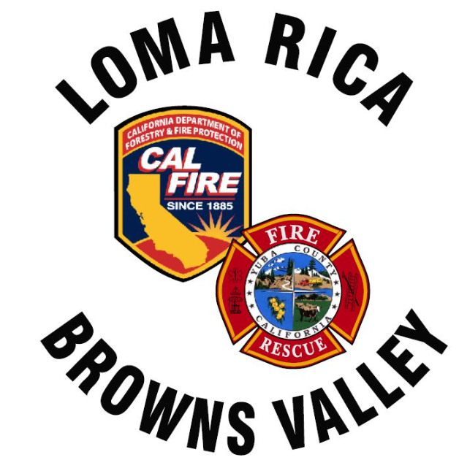
Monthly Report for LRBV

Month/Year: June, 2026

 | St. 61
Medical Aid | 37
Public Assists | 10
Medical Rescues | 0
Vehicle Accidents | 5
Structure Fires | 3
Vegetation Fires | 9
Vehicle Fires | 3
False Alarms | 2
Hazardous Conditions | 0
Hazardous Materials | 0
Cover Assignments | 2
Assist to Allied Agency | 0
Total Responses | 46

News:
WT 61 is no longer on track for late July delivery due to a supply chain issue with the axels.
E63 ABH behind Strike team to Colorado. Min 14 day rental for the District.
Potential buyer is seeking financing for engine. Have yet to hear back….
Tablet command install going well, E63 and E61 are complete

